Bradford City Mental Health Supporters Group - Referral Form

Please complete this form and return – via e-mail – to mentalhealthsupportersgroup@bradfordcityafc.com.

Following completion and return of this form - to mentalhealthsupportersgroup@bradfordcityafc.com - you will receive an appointment date of a non-clinical, advisory consultation with our Mental Health Ambassador within 72 hours. Please allow up to four weeks for actual consultation.

If you require immediate assistance, please contact either:
- Your Doctor’s surgery
- NHS - 111
- Samaritans - 116 123
- Mind - 0300 123 3393
- First Response - 0800 952 1181

All personal information and consultations will be confidential and not shared with any third party, unless the safeguarding lead or mental health clinician believes the individual to be at immediate risk.

Name:

Address:

Date of birth:

E-mail address:

Telephone number:

Are you currently receiving acute clinical intervention from a GP or Mental Health Team?
Yes / No. If yes, please provide details.

Reason for wanting to speak to a Mental Health Ambassador?

Please tick the appropriate box for the preferred method of communication.
Phone / E-mail

Do you consent to be contacted by our Mental Health Ambassador upon completion of this referral form?
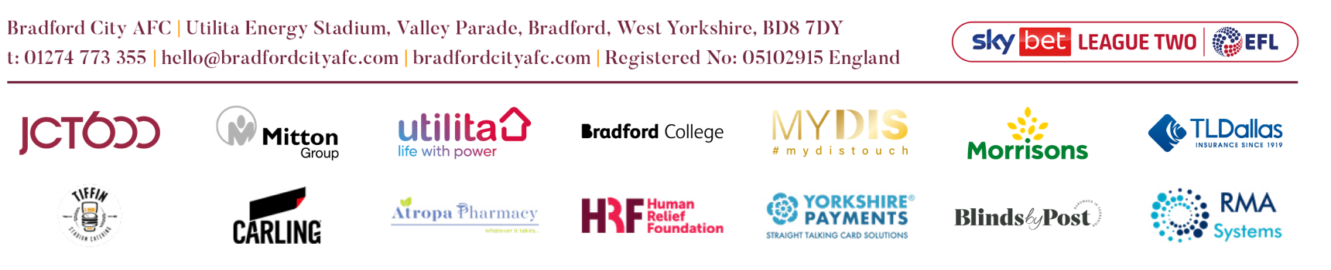
Yes / No

